NAME: AKINBODE OLAJUMOKE ADESOLA
DEPARTMENT: NURSING SCIENCE
MATRIC NUMBER: 18/SCI05/002
COURSE TITLE: PHYSIOLOGY
COURSE CODE: PHS 212

The Physiology of Balance: Vestibular Function
The ear is a sensory organ that picks up sound waves, allowing us to hear. It is also essential to our sense of balance: the organ of balance (the vestibular system) is found inside the inner ear. It is made up of three semicircular canals and two otolith organs, known as the utricle and the saccule. The semicircular canals and the otolith organs are filled with fluid.
The vestibular system is the sensory apparatus of the inner ear that helps the body maintain its postural equilibrium. The information furnished by the vestibular system is also essential for coordinating the position of the head and the movement of the eyes. There are two sets of end organs in the inner ear, or labyrinth: the semicircular canals, which respond to rotational movements (angular acceleration); and the utricle and sacculewithin the vestibule, which respond to changes in the position of the head with respect to gravity (linear acceleration). The information these organs deliver is proprioceptive in character, dealing with events within the body itself, rather than exteroceptive, dealing with events outside the body, as in the case of the responses of the cochlea to sound. Functionally these organs are closely related to the cerebellum and to the reflex centres of the spinal cord and brainstem that govern the movements of the eyes, neck, and limbs.
- 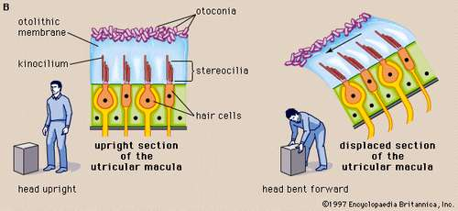
- 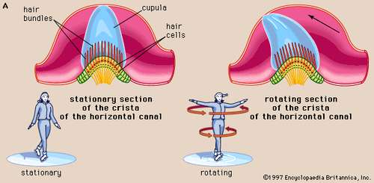
In vertebrates the utricular maculae in the inner ear contain an otolithic membrane and otoconia (particles of calcium carbonate) that bend hair cells in the direction of gravity. This response to gravitational pull helps animals maintain their sense of balance.
The cristae of the semicircular ducts, which form one of the two sensory organs of balance (the second being the maculae of the utricle and saccule), respond to rotational movements and are involved in dynamic equilibrium.
Structure of the ear and the vestibular system

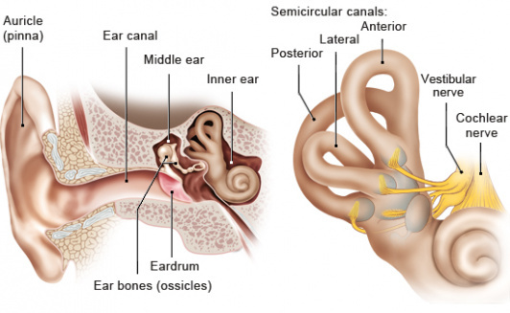

Each of the semicircular canals end in a space that has small hair cells in it. These spaces are called ampullae. Whenever we turn our head, the inner ear turns along with it. But it takes a very brief moment for the fluid in the semicircular canals and ampullae to move with our head too. This means that the sensory hair cells in the ear are bent by the “slow” fluid. The hair cells then send this information to the brain via nerves.
Each of the three semicircular canals is responsible for a specific direction of head movement: One of the canals responds to the head
- tilting upwards or downwards,
- one responds to it tilting to the right or to the left, and
- one responds to it turning sideways.
The otolith organs are found diagonally under the semicircular canals and have a similar function: There are also thin sensory hair cells in both organs. The difference is that, unlike in the semicircular canals, there are small crystals on the hair cells – like pebbles on a carpet. These crystals are called otoliths or “ear rocks.” The otolith organs detect acceleration, for instance when you take an elevator, fall, or gather speed or brake in a car.
Information coming from the vestibular system is processed in the brain and then sent on to other organs that need this information, such as the eyes, joints or muscles. This allows us to keep our balance and know what position our body is in.
In some situations, for example on a ship or airplane, different sensory organs (e.g. the eyes and the organ of balance) send contradictory messages to the brain. This can cause us to feel unwell, dizzy or nauseous.
The vestibular system is especially sensitive in children, and reacts more slowly to movements as we grow older. Inner ear infections and other problems may also affect how well our sense of balance works.

